DSA 0601 - Data handling and visualization
Set 4 - Product Inventory Management

Name : B.Jahnavi
Reg.no:192325043

- Bar Chart
Code:

library(ggplot2)
inventory <- data.frame(
Product_ID = c(1, 2, 3, 4, 5),
Product_Name = c(
"Product A",
"Product B",
"Product C",
"Product D",
"Product E"
),
Quantity_Available = c(250, 175, 300, 200, 220)
)

ggplot(
inventory,
aes(x = Product_Name, y = Quantity_Available)) +
geom_bar(
stat = "identity",
fill = "steelblue" ) +
labs(
title = "Product Inventory", x = "Product Name", y = "Quantity Available"
) + theme_minimal()

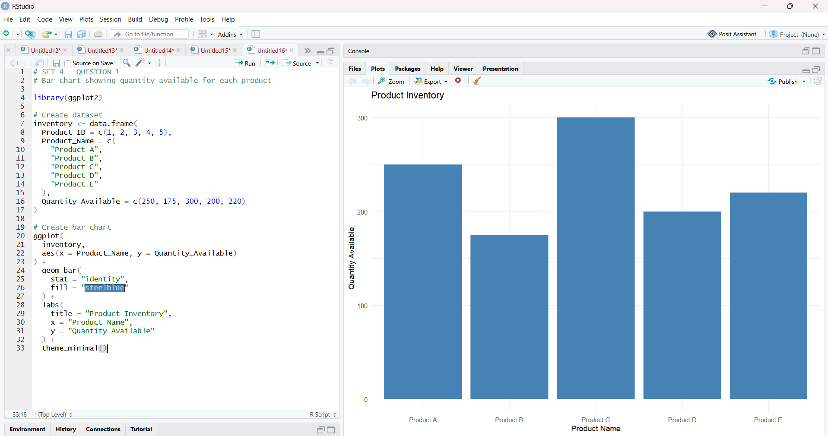

- Stacked Bar Chart by Product Category
Code:

library(ggplot2)
inventory <- data.frame(
Product_ID = c(1, 2, 3, 4, 5),
Product_Name = c(
"Product A",
"Product B",
"Product C",
"Product D",
"Product E"
),
Category = c(
"Category 1",
"Category 1",
"Category 2",
"Category 2",
"Category 3"
),
Quantity_Available = c(250, 175, 300, 200, 220)
)
ggplot(
inventory,aes( x = Category, y = Quantity_Available,fill = Product_Name)) +
geom_bar(stat = "identity"
) + labs(
title = "Inventory Quantity by Product Category",
x = "Product Category",
y = "Quantity Available",
fill = "Product") + theme_minimal()

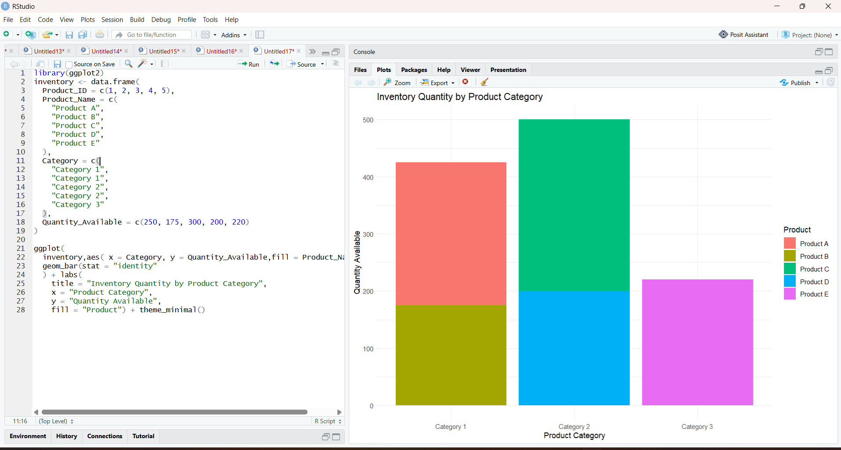

- Scatter Plot: Price vs Quantity
Code:

library(ggplot2)
inventory <- data.frame(
Product_ID = c(1, 2, 3, 4, 5),
Product_Name = c(
"Product A",
"Product B",
"Product C",
"Product D",
"Product E"
),
Price = c(100, 150, 80, 120, 200),
Quantity_Available = c(250, 175, 300, 200, 220))
ggplot(inventory,
aes(
x = Price,y = Quantity_Available,label = Product_Name)) +
geom_point(
size = 4
) +
geom_text(
vjust = -0.8
) +
labs(
title = "Relationship Between Product Price and Quantity Available",
x = "Product Price",
y = "Quantity Available"
) +
theme_minimal()

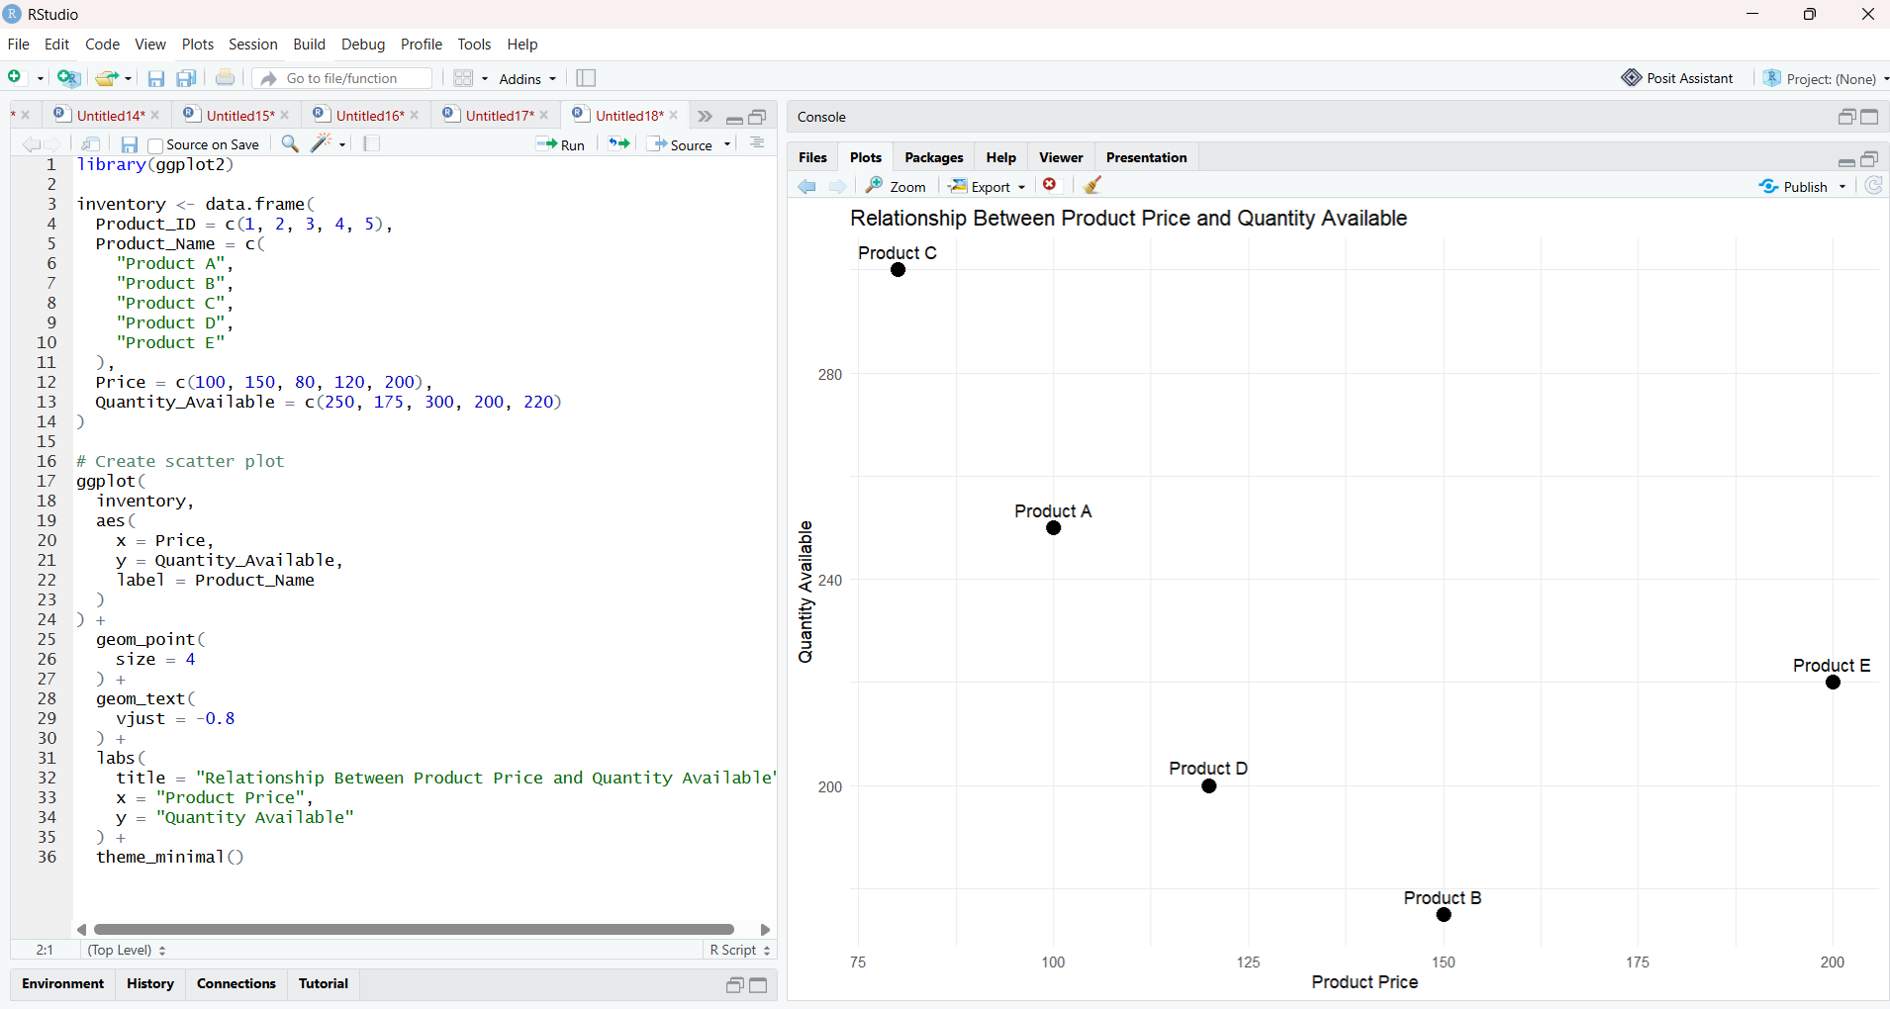

- Tableau Dashboard
Code:

inventory <- data.frame(
Product_ID = c(1, 2, 3, 4, 5),
Product_Name = c(
"Product A",
"Product B",
"Product C",
"Product D",
"Product E"
),
Quantity_Available = c(250, 175, 300, 200, 220)
)

# Save as CSV
write.csv(
inventory,
"Product_Inventory.csv",
row.names = FALSE
)

print("Product_Inventory.csv created successfully!")

